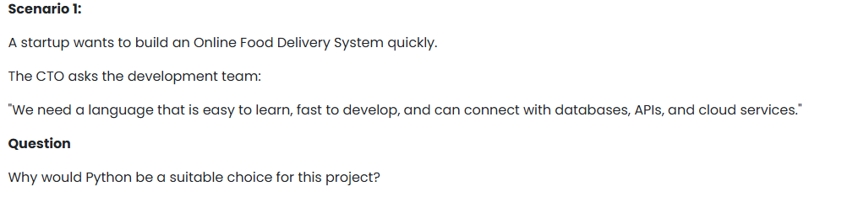
**Answer (Easy Way):**
Python is a suitable choice for an Online Food Delivery System because:
* It is easy to learn and use, so developers can build the project quickly.
* Python allows fast development, which helps the startup launch its system sooner.
* It can easily connect with databases like MySQL and PostgreSQL.
* Python supports APIs making it easy to communicate with mobile apps and other services.
* It works well with cloud platforms such as AWS and Google Cloud.
* Frameworks like Django and Flask provide many built-in features, reducing development time.

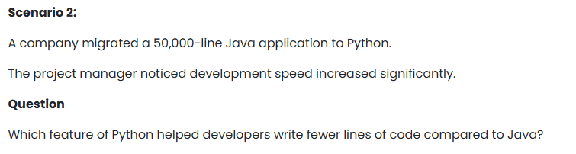
• Python code is shorter and easier to read.
• It requires less boilerplate code than Java.
• Developers can complete tasks with fewer lines of code.

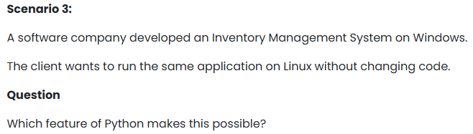
• ython programs can run on different operating systems like Windows, Linux, and macOS.
• The same code can be used without major changes.
• This saves time and effort during deployment.

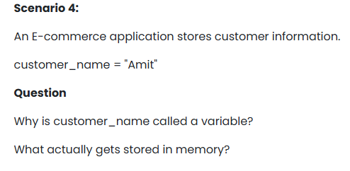
- customer_name is called a variable because it is a named container used to store data, and its value can change during program execution.
- In the statement customer_name = "Amit", customer_name is the variable name.
What gets stored in memory?
- The value "Amit" (the string) is stored in memory.
- The variable customer_name refers to or points to that stored value.
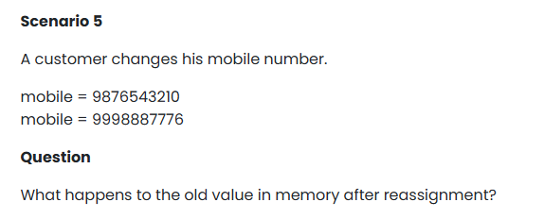
When the variable is reassigned:
mobile = 9876543210
mobile = 9998887776
- The variable mobile stops referring to the old value 9876543210.
- It now refers to the new value 9998887776.
- If no other variable is using the old value, Python automatically removes it from memory through Garbage Collection.
Conclusion: After reassignment, the old value is no longer referenced by mobile and is eventually removed from memory by Python's garbage collector.
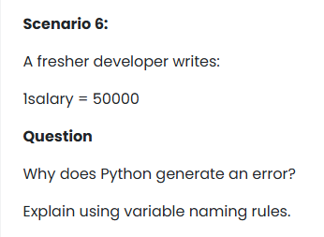
Error explanation:
Python reads 1salary and expects a number (1), but then encounters letters (salary), which makes the syntax invalid.
Answer: Python generates an error because the variable name 1salary starts with a number, which violates Python's variable naming rules.
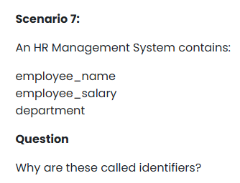
These are called identifiers because they are names used to identify different items in a program or system.
In the HR Management System:
- employee_name identifies the employee's name.
- employee_salary identifies the employee's salary.
- department identifies the department information.
An identifier is a user-defined name given to variables, functions, classes, or other program elements so they can be referenced and used in the code.
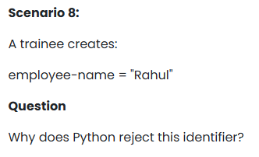
Python rejects the identifier employee-name because it contains a hyphen (-), which is not allowed in variable names.
In Python, identifiers:
- Can contain letters, digits, and underscores (_).
- Cannot contain special characters such as -, @, #, $, etc.
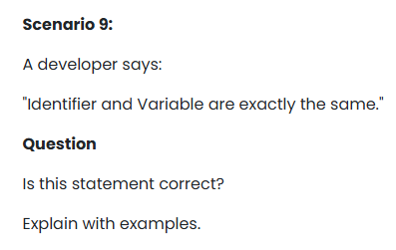
Identifier | Variable
A name used to identify program elements such as variables, functions, classes, etc. | A named storage location that holds a value.
It is just a name. | It stores data.
Every variable name is an identifier. | Every variable uses an identifier as its name.

